

**Pokhara University Affiliate**

**LA GRANDEE INTERNATIONAL COLLEGE**

**Simalchaur, Pokhara Nepal**

A Final Report On

**“BakeWise”**

**Submitted to:**

Bachelor of Computer Application (BCA) Program

In partial fulfilment of the requirements for the degree of BCA under

Pokhara University

**Submitted by:**

|  |  |  |  |
| --- | --- | --- | --- |
| **Name:** | **Course** | **Semester** | **P.U. Registration Number** |
| Aakriti Parajuli | BCA | 6th | 2021-1-53-0345 |
| Sambhawi Baral | BCA | 6th | 2021-1-53-0365 |
| Rebecca Ghimire | BCA | 6th | 2021-1-53-0361 |
|  | **Date:1/19/25** |  |  |

# **Acknowledgement**

We express our gratitude toward the department of Bachelor in Computer Application, Pokhara University, LA Grandee International College for granting us with an opportunity to work on a project as for the fulfilment of the requirement for the degree.

We sincerely thank our faculty teacher and supervisor **Mr. Sunil Sapkota** and **BCA Co-ordinator Mr. Kundan Chaudary** for encouraging and guiding us. And we appreciate and we are thankful toward each other, we worked as a team supportively.

Sincerely,

Aakriti Parajuli (2021-1-53-0345)

Sambhawi Baral (2021-1-53-0365)

Rebecca Ghimire (2021-1-53-0361)

**Declaration for**

**“Bakery Management System”**

# **Student’s Declaration**

We hereby declare that we are the only authors of this work and that no source other than the listed here have been used in this work.

**Name of the student:** Aakriti Parajuli

**Class Roll No:** 1

**Exam Roll No:** 21535166

**Semester:** 6th

**Signature:**

**Name of the student:** Sambhawi Baral

**Class Roll No:**

**Exam Roll No:** 21535146

**Semester:** 6th

**Signature:**

**Name of the student:** Rebecca Ghimire

**Class Roll No:** 22

**Exam Roll No:** 21535162

**Semester:** 6th

**Signature:**

Date:1/19/25

# **Supervisor’s Declaration**

I hereby recommended that this project entitled “**Bakery Management System**” is done under my supervision by **Rebecca Ghimire, Aakriti Parajuli, Sambhawi Baral** during their 6th semester in partial fulfilment of the requirements for the degree of **Bachelors in Computer Application (BCA)** under **Pokhara University** is completed to my satisfaction and be processed for final evaluation.

____________________________

**Mr. Sunil Sapkota**

**Date:1/19/25**

# **Letter of Approval**

We certify that we have examined this report entitled “**Bakery Management System**” and are satisfied with the project defense. It is satisfactory in the scope and quality as project in partial fulfilment of the requirement for the degree of **BCA** under **Pokhara University.**

|  |  |  |
| --- | --- | --- |
| ___________________  **Mr. Sunil Sapkota**  **Supervisor** | ____________________  **External Examiner** | _____________________  **Mr. Kundan Chaudhary**  **Program Coordinator** |

**Date: 21/02/2024**

# **Abstract**

**Bakery Management System** is the way of reducing the workload environment and enhancing the working system. By addressing the challenges faced by traditional bakery operations, these platforms can help bakeries stay competitive in today’s fast placed market. The primary goal of this project is to provide a comprehensive bakery management system through this platform, built with PHP, HTML, JavaScript, CSS and MySQL.

**Table of Contents**

**Acknowledgement** ii

**Student’s Declaration** iii

**Supervisor’s Declaration** iv

**Letter of Approval** v

**Abstract** vi

**1** **Introduction** 1

**2** **Problem Statement** 2

**3** **Objectives** 3

**4** **Background Study** 4

**5** **Requirement Documents** 5

**5.1 Functional Requirements** 5

**5.2 Non-Functional Requirements** 6

**6** **System Design** 7

**6.1.** **DFD** 7

**6.2** **ER Diagram** 11

**6.3** **Use Case Diagram** 12

**7.** **Development** 13

**7.1.** **Methodology** 13

**7.2** **Project Gantt Chart** 16

**8.** **Testing** 17

**9.** **Project Result** 21

**10** **Future Enhancements** 22

**11** **Conclusion** 23

**12** **References** 25

**List of figures**

**List of tables**

**Abbreviations**

|  |  |
| --- | --- |
| HTML | Hypertext Markup Language |
| Css | Cascading style sheet |
| PHP | Hypertext Preprocessor |
| Mysql | My Structured Query Language |
| DFD | Data flow diagram |
| ER | Entity relationship |

# **Introduction**

A Bakery System Management ecommerce platform is a valuable tool for bakery businesses looking to improve efficiency, enhance customer satisfaction and drive growth. **Bakery Management System** is the way of reducing the workload environment and enhancing the working system. By addressing the challenges faced by traditional bakery operations, these platforms can help bakeries stay competitive in today’s fast placed market.

The bakery management system is designed to streamline and automate the daily operations of a small bakery. The system is especially suited for small bakeries with a limited number of employees, helping to ensure that all operations run smoothly and efficiently.

The system allows the customer to shop online and browse the available products. Through this system, bakery owners can track customer orders and manage inventory levels effectively, and ensure better customer experience. The user-friendly interface allows bakery owners to manage their business operation from any location, providing greater flexibility and control.

The primary goal of this project is to provide a comprehensive bakery management system through this platform, built with php, html and css. Built using php, this system provides bakery owners with an efficient way to manage key aspects of their business, including customers, orders, products and inventory. This solution not only simplifies the operational management of a bakery but also enhances the overall customer experience by offering secure, efficient order fulfillment.

The system allows the admin to manage products, orders and view reports efficiently, whereas the customers can view the product create the wish-list and can purchase the item. The system will not only modernize the bakery’s operations but also help the business scale by reaching a wider audience through the internet.

A local bakery wants to digitize its operations by creating an e-commerce platform that allows customers to browse and orders, which limits its growth and reach. With increasing demand and competition, the bakery needs an efficient system that allows customers to order products at their convince. As well local bakeries struggle to reach a large audience and handle online audience and handle online orders efficiently. Customers prefer the convenience of ordering products online, but many bakeries don’t have the technology to offer this service. Therefore, Bakery Management System is built.

# **Problem Statement**

There has been a significant change and shift towards online shopping, including food-related purchases. Small bakeries need to adapt to this trend to stay competitive. Various existing platforms provide e-commerce services, but this project aims to cater specifically to bakery needs.

* Customers Service Challenges: Difficulty in managing customer orders, providing timely customer support and maintaining customer satisfaction.
* Poor interface: The websites that exits are difficult to use by the customer due to its poor interface and features.

1. **Objectives**

The objective of this project is to develop a bakery e-commerce platform using php, css, html that will allow customers to easily browse, order, and see the availability for bakery products online. To improve business flexibility with a user friendly interface that allows bakery owners to manage operation remotely. Enchance customer experience. The main objective of this project:

* Built a user-friendly bakery e-commerce website.
* Allow customers to view and purchase bakery items online.

# **Background Study**

**Bakery Management System** is a system based on digital technology with the aim of automating and improving all activities involved in the operation of a bakery, including restock control, order processing, sales control, and control of relationships with customers. As the baking industry grows in size and as the demand for baked products increases, so too does the demand for efficiency to capture orders, manage stock levels, and optimize customer preferences, this system offers a single interface to increase output and maintain seamless operations. It also has capabilities related to online ordering.

# **Requirement Documents**

We collected several requirements for project from our primitive research, website visits, and interview to the concerned personnel and their experiences regarding the concepts of its development. Here, we analysed, documented, validated, and managed software or system requirements.

## **5.1 Functional Requirements**

The description of the services that the system should provide to the user. Some functional requirements are:

* **User Registration**

Users can log in and can view the products but cannot manipulate the data.

* **R**

T

* **R**

Notify

* **Admin Login**

Admin can enter the username and password to get access of the system.

## **5.2 Non-Functional Requirements**

Non-Functional requirements are set of specifications that describe the system’s operation capabilities and constraints and attempt to improve its functionality. Some non-functional requirements are:

* **Usability**

The system will provide user friendly interface for customers.

* **Portability**

The system will be able use on different platforms without change in its behavior or performance.

* **Security**

Sensitive data are safe, user authentication.

# **System Design**

System Design is the one of phases in the developing of system. It is the process of designing the elements of a system such as modules, interfaces and the data that goes through that system.

## **DFD**

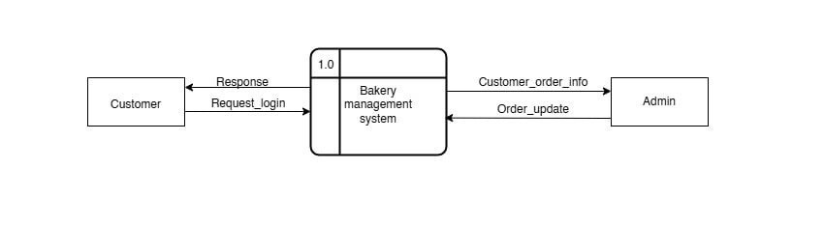

Figure 6.1 level-0-DFD

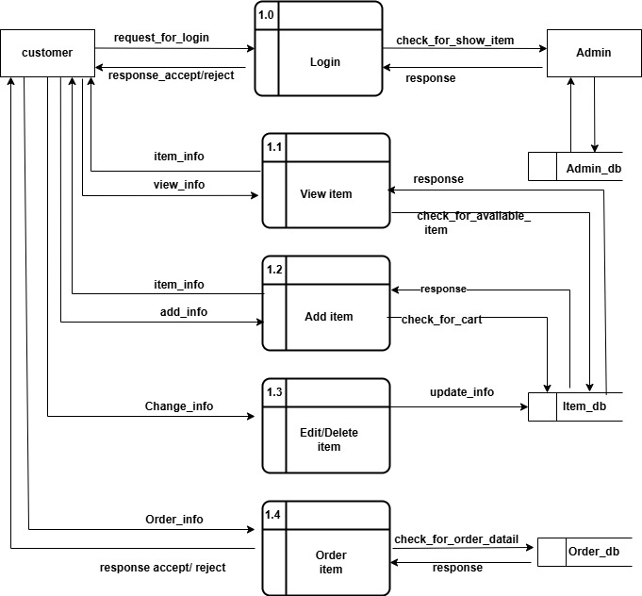

Figure 6.2 level-1-DFD

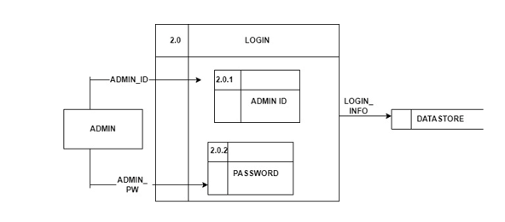

Figure 6.3 level-2-DFD login

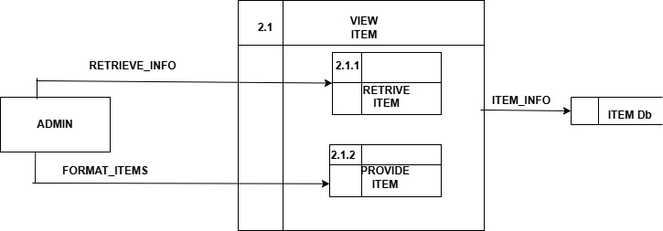

Figure 6.4 level-2-DFD view

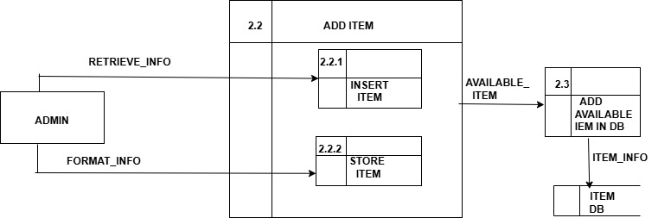

Figure 6.5 level-2-DFD add item

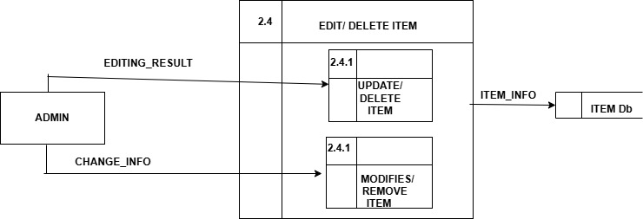

Figure 6.6 level-2-DFD edit/delete item

## **ER Diagram**

An Entity Relationship Diagram is a diagram that represents relationships among entities in a database. It is commonly known as an ER Diagram.

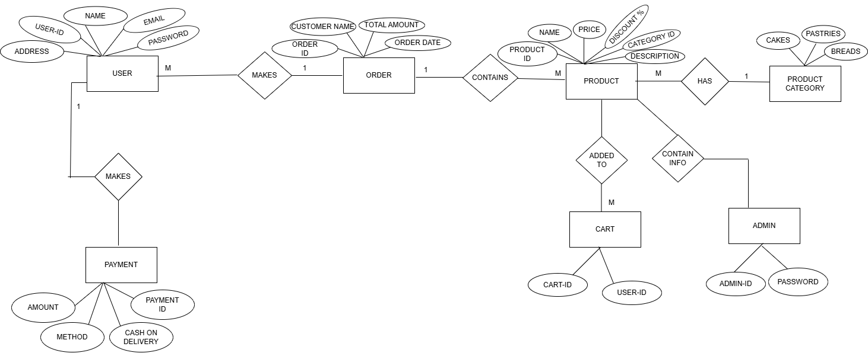

Figure 6.7 ER Diagram

## **Use Case Diagram**

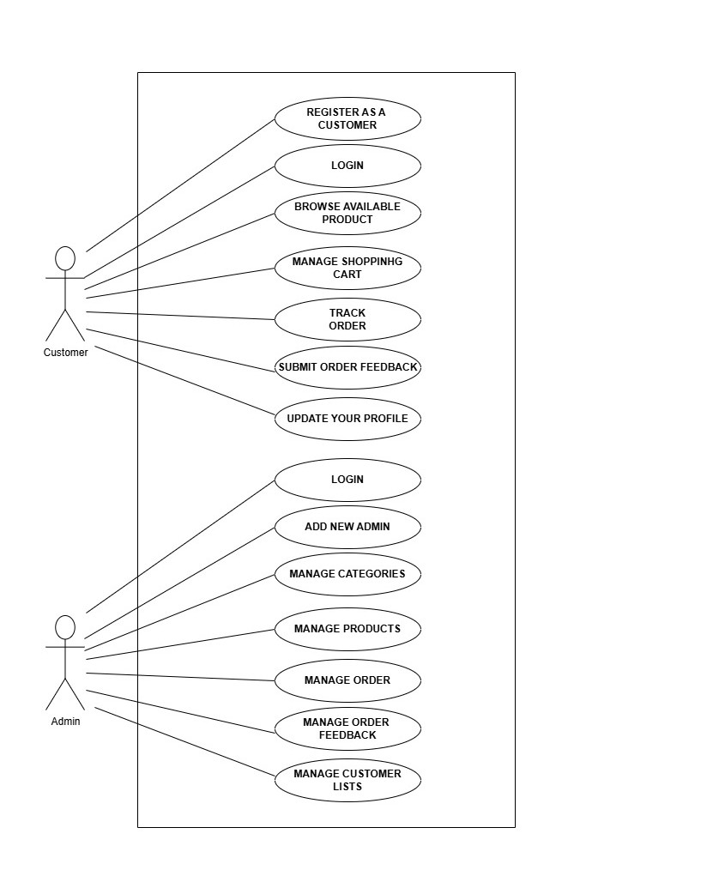

Figure 6.8 Use case diagram

# **Development**

## **Methodology**

Spiral model is a risk driven software development process model. It provides a framework for designing processes including the risk levels associated with them. A spiral model is a cyclic model. It allows the rapid generation of subsequent phases during the software development phases. It also allows checking the robustness and correctness of the phases. After each cycle a prototype is developed and checked for its robustness and to meet the requirements.

Phases of the spiral model:

* Objectives Defined: In first phase of the spiral model clarify what the project aims to achieve, including functional and non-functional requirements.
* Planning Phase: All the required information about the project will be gathered in this phase. Requirements such as system requirement specifications, design alteration, etc. will be done in this phase
* Risk Analysis: Requirements of the project is studied and brainstorm sessions are conducted to figure out potential risks involved. In the risk analysis phase, the risks associated with the project are identified and evaluated at the beginning of each iteration, and appropriate actions are taken to mitigate them.
* Engineering: In the engineering phase, the software is developed based on the requirements gathered in the previous iteration.
* Testing Phase: Testing alongside developmental changes will be done in this phase. Coding, test case development, test execution, test summary report, defect report generation, etc. happens in this phase.
* Evaluation: In the evaluation phase, the software is evaluated to determine if it meets the customer’s requirements and if it is of high quality. Feedback is gathered and used to refine the requirements for the next iteration.

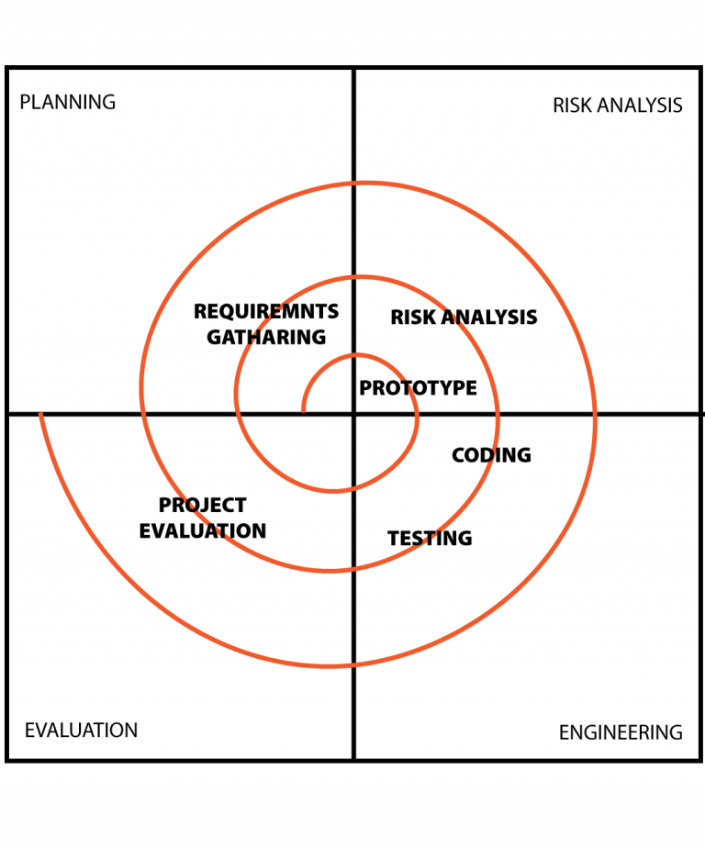 (testbytes, 2019)

Figure 7.1 Spiral model

* Each spiral that can be seen in the diagram above acts as a loop for a separate process in testing. The four main activities, planning risk analysis, testing, coding and project evaluation will be repeated again for the required number of phases for any project.

**How it Works in Practice:**

1. **Start with a small, initial release:** This could be a prototype or a minimal viable product (MVP).
2. **Gather feedback:** Collect feedback from users and stakeholders.
3. **Analyze risks:** Identify and address any potential issues or challenges.
4. **Iterate and refine:** Based on feedback and risk analysis, refine the software and develop the next iteration.
5. **Repeat the process:** Continue iterating through the spiral, gradually adding features and improving the software based on feedback and risk assessments.

## **Project Gantt Chart**

The Gantt chart below shows the schedule planned for developing the “Bakery Management system”. This project would be carried out in steps with proper planning in each step, best effort would be applied to finish this project before deadline.

Figure 7.2 Gantt chart

1. **Testing**

Software testing is the process of evaluating a software product to ensure it functions as intended. It involves running test cases to identify bugs and verify that the software meets expectation.

The following test cases that are performed:

**Test Cases**

**Test case 1**

**Title:** Module testing of a Login function– Authentication of users

**Description:**A user should be able to log in with a registered email and password.

|  |  |  |  |  |  |
| --- | --- | --- | --- | --- | --- |
| Test Case ID | Test Case Description | Preconditions | Test Steps | Expected Result | Status |
| TC001 | User login with valid credentials | User has a registered account | 1. Navigate to the "Login" page 2. Enter valid email and password 3. Click the "Login" button | User is redirected to the dashboard | Login successful |
| TC002 | User login with invalid email | User has a registered account | 1. Navigate to the "Login" page 2. Enter an invalid email format (e.g., invalid-email) 3. Click "Login" | Error message displayed: "Invalid email format." | Login unsuccessful |
| TC003 | User login with unregistered email | No account exists for the entered email | 1. Navigate to the "Login" page 2. Enter an unregistered email 3. Enter any password 4. Click "Login" | Error message displayed: "Email not found." | Login unsuccessful |
| TC004 | |  | | --- | | Prevent login with empty fields |  |  | | --- | |  | | None | 1. Navigate to the "Login" page 2. Leave the email and password fields empty 3. Click "Login" | Error message displayed: "All fields are required." | Login unsuccessful |

**Test Case 2**

**Title:** Module Testing of Dashboard function –Admin Add New Products

**Description:** An admin should be able to add the new products.

|  |  |  |  |  |  |
| --- | --- | --- | --- | --- | --- |
| Test Case ID | Test Case Description | Preconditions | Test Steps | Expected Result | Status |
| TC005 | Add a new product to the bakery inventory | Admin user logged in | 1. Navigate to "Add Product" page 2. Fill in product details 3. Submit the form | Product is added to the inventory and displayed in the product list | Adding the item is successful. |

**Test Case 3:**

**Title:** Module Testing of Dashboard function: View Products Details

**Description**: A user can view the products.

|  |  |  |  |  |  |
| --- | --- | --- | --- | --- | --- |
| Test Case ID | Test Case Description | Preconditions | Test Steps | Expected Result | Status |
| TC006 | Add a new bakery item with all valid inputs | Admin is logged in | 1. Navigate to the "Add New Item" page 2. Enter valid item name, price, and details 3. Upload a valid image 4. Click "Submit" | Bakery item is added and displayed in the item list | Viewed details successfully. |

**Test Case 4:**

**Title:** Module Testing of Dashboard function: Edit Bakery Items Details

**Description:** An admin should be able to update the items details.

|  |  |  |  |  |  |
| --- | --- | --- | --- | --- | --- |
| Test Case ID | Test Case Description | Preconditions | Test Steps | Expected Result | Status |
| TC007 | Edit bakery item with valid details | Admin user logged in | 1. Navigate to the "Bakery Items" list 2. Click "Edit" on a specific item 3. Update valid details 4. Click "Save" | Bakery item details are updated and displayed correctly in the list | Updated successfully. |

**Test Case 5:**

**Title:** Module Testing of Dashboard Function: Delete Details

**Description:** An admin can delete the products.

|  |  |  |  |  |  |  |  |
| --- | --- | --- | --- | --- | --- | --- | --- |
| Case ID | Test Case Description | |  | | --- | | Preconditions |  |  | | --- | |  | | Test Steps | Expected Result | Status |
| TC008 | Delete a bakery item successfully | Admin user is logged in and has access to the dashboard | 1. Navigate to the "Bakery Items" section on the dashboard 2. Locate an item to delete 3. Click the "Delete" button 4. Confirm the deletion in the confirmation dialog | |  | | --- | | The item is deleted successfully and no longer appears in the item list |  |  | | --- | |  | | Deleted details successfully. |

**Test Case 6:**

**Title:** Module Testing of Dashboard Function: Exit

**Description:** A system will be stopped if the exit operation is done.

|  |  |  |  |  |  |
| --- | --- | --- | --- | --- | --- |
| Test Case ID | Test Case Description | Preconditions | Test Steps | Expected Result | Status |
| TC009 | User exits the dashboard successfully | User is logged in and, on the dashboard, | 1. Click the "Exit" or "Logout" button on the dashboard 2. Confirm the action if prompted | User is logged out and redirected to the login page | User will exit from the dashboard. |

# **Project Result**

In this project, BakeryManagement System, we have introduced what is project about, and have mentioned about its problems and objectives.

Bakery management system bakery products and it’s details where customers can view and purchase the products.

Requirements (functional and non-functional) for the system has been written. The spiral model is used in this project.

ER diagram has shown the relationship between the entities, it shows the simple overview of the system.

Use case diagram has captured and modeled and specified the requirements of the system.

The Gantt chart has showed the schedule planned for developing the “Bakery Management system”.

**Admin**

The system will help the bakery owner/admin manage the business more effectively by providing tools to:

* Add and update product listings.
* View and manage products and customer orders.
* Managing inventory and updating product availability.
* Integrating a user-friendly interface for customers to place orders.

**Customer**

* Users can login, ensuring secure user authentication.
* Where users are offered a wide range of products (cakes, bread, cookies, pastries, etc.) online.
* Customer can view, browse, add product for purchase.
* Customers can add to cart the products or can add in the Wishlist can also remove.
* Provide a seamless and intuitive shopping experience.

1. **Future Enhancements**

As the project progresses, there may be opportunities to enhance the functionality and user experience of the system. The following are potential future enhancements that can be considered to improve the overall utility of the application.

* Track sales data and generate reports.
* Able online payment methods.
* We will add more features for the users where users may edit there details.

# **Conclusion**

In conclusion, the bakery management system successfully achieves its objectives by providing a user-friendly e-commerce platform that streamlines the purchasing experience for customers and enhances operational flexibility for bakery owners. By imposing PHP, HTML, and CSS, the system enables customers to browse, order, and check the availability of products online, creating a seamless shopping experience. Additionally, it empowers bakery owners to manage operations remotely, boosting business efficiency and adaptability. This solution not only meets the immediate needs of the bakery but also establishes a foundation for improved customer satisfaction and business growth in the digital era.

# **References**

Kumar, A. (2015). *online cake bakery management system in PHP*. Retrieved from PHPGurukul.com: https://phpgurukul.com/

testbytes. (2019). Retrieved from testbytes: https://images.app.goo.gl/T7B1Bmu13N2iwGjc7